An exploratory analysis of customer preferences towards shopping centres

SAS Data Analysis

B924622-22BSP411-CW1

**Contents**

1. **Executive Summary……………………………………………………...2**
   1. **Introduction………………………………………………………………………...2**
   2. **Main Body…………………………………………………………………………..2**
   3. **Recommendations………………………………………………………………..5**
2. **Technical Appendix……………………………………………………...6**
   1. **Structure……………………………………………………………………….……6**
   2. **Uploading and cleaning the data………………………………….……………6**
   3. **One-way frequencies……………………………………………………………..7**
   4. **Testing association……………………………………………………………….7**
   5. **Assumptions and Justifications……………………………...........................7**
3. **Annotated SAS Output…………………………………………………..9**
   1. **Location………………………………………………………………………….….9**
   2. **Potential companies…………………………………………………………….12**
   3. **Facilities/amenities and layout………………………………………………..16**
4. **Appendix…………………………………………………………….……19**
5. **References……………………………………………………………….20**

**Executive summary**

**Introduction**

The purpose of this report is to explore the questionnaire data provided by the property developer company, that plans to build a shopping centre, to help them make the following key decisions:

1. Choosing an appropriate location for the shopping centre
2. Identifying the potential companies that may be interested in renting a store
3. Designing the centre’s facilities/amenities and layout

The report will focus on analysing the dataset thoroughly using statistical methods and provide the key findings and recommendations. Next, there will be a technical appendix that details the steps followed to produce the analysis in SAS as well as any assumptions made throughout. This is followed by annotated SAS output containing relevant supporting material from the software used to perform the analysis.

Overall, the survey data has been successful in identifying participants preferences regarding shopping centres and has the basis to be used in aiding the property developer make their key decisions. This study has found that generally potential customers in this town are more concerned with what is offered by the shopping centre rather than where it is located. Specifically, they are willing to travel further distances to shopping centres that provide high quality products with great value for money, granted there are suitable routes to get there and convenient parking present. Furthermore, having shops that are varied and offer a range of goods will attract the widest group of potential customers.

1. **Choosing an appropriate location for the shopping centre**

Having convenient parking is an important factor for potential shoppers. Specifically, 67% of respondents felt having convenient places to park in a shopping centre was either ‘Very important’ or ‘Important’, with another 21% answering with ‘Slightly important’. Participants felt similarly about the availability of good road links, however, not as strongly as convenient parking. For example, the modal response of having good road links to the shopping centre was ‘Slightly important’ (32.02%) with the next most common response being ‘Important’ (30.56%). Additionally, car owners were statistically more likely to respond strongly about these than non-car owners, however, non-car owners still perceived these two as necessary factors in a shopping centre. Furthermore, there is a medium association between participants views concerning the importance of having convenient parking and whether they owned cars, whereas with good road links this association is relatively weak. Therefore, depending on whether individuals owned cars, preferences on convenient parking were more likely to change compared to those on having good road links.

Next, respondents reacted quite passively towards having shopping centres closer to their homes. This is characterised with 65% of respondents perceiving it as either ‘Slightly important’ or ‘Slightly unimportant’. Therefore, regarding location, potential shoppers are not against travelling a reasonable distance to get to the shopping centre.

Finally, respondents’ perception of having good public transport links to shopping centres was relatively even. Specifically, 51.77% of participants felt it was either ‘Slightly unimportant’, ‘Unimportant’ or ‘Very unimportant’, with the rest viewing them as necessary. There was a relatively medium association between not owning a car and perceiving public transport as necessary. Car owners were statistically more likely to view it as unimportant whereas non-car owners were more likely to view it as important. Additionally, there was a medium association between non-homeowners and views on good public transport links. More precisely, non-homeowners are statistically more likely to have stronger feelings on whether good public transport links are necessary or not. However, for both instances the perceptions are still relatively even with no group significantly skewing to one side.

1. **Identifying the potential companies that may be interested in renting a store**

The most important feature in a shopping centre to customers is having value for money. This is characterized by 83.16% of respondents perceiving it as either ‘Important’ or ‘Very important’, with an additional 14.14% answering it as ‘Slightly important’. Additionally, participants seemed to prefer this to having bargains within a shopping centre, where only 55.3% perceived this as ‘Important’ or ‘Very important’.

The next most important feature is High quality goods as the modal response was ‘Important’ (46.99%) with another 33.26% of responses being ‘Very important’. Furthermore, respondents prioritised this compared to having a wide range of goods or shops. With 76.3% of all responses for having a wide choice of goods being either ‘Important’ or ‘Very important’ and 74.85% from having a wide choice of shops falling in these categories it is observable that participants still perceived these as important features to have in a shopping centre. However, there was a medium association between both these factors and whether participants owned homes. Specifically, non-homeowners are statistically more likely to find having a variety of shops and goods important compared to homeowners.

Participants viewed large departmental stores as necessary features of a shopping centre as 69.03% of responses were either ‘Important’ or ’Slightly important’. However, respondents did not feel particularly strongly about them with only 7.07% of answers being ‘Very important’. Additionally, a medium association was present between participants who owned a home and their preference on large department stores in shopping centres. Non-homeowners were statistically more likely to perceive having large department stores as necessary feature in a shopping centre. There was a perceivable difference in the attitudes between this and those of having large supermarkets in shopping centres. Respondents did not view large supermarkets as very necessary with relatively passive opinions. Specifically, 63.62% of all responses were either ’Slightly unimportant’ or ‘Slightly important’. Small specialist stores were viewed as more favourable compared to large supermarkets/hypermarkets, however perceptions were still divided on whether they were necessary in a shopping centre. For example, the modal response was ‘Slightly Important’ (30.53) with the next most common answer being ‘Slightly unimportant’ (24.74%).

Having public houses seems to be important to respondents but not as necessary as some of the previously mentioned features. For example, 47.4% of all responses were either ‘Important’ or ‘Slightly important’, with a further 13.93% responding with ‘Very important’. Respondents viewed having cafes in the shopping centre in a similar regard, with 44.9% of responses being either ‘Important’ or ‘Slightly important’. However, statistically respondents were more partial to public houses compared to cafes. Additionally, there is a medium association between these two features and whether participants own homes. Specifically, homeowners were statistically more likely find public houses important and cafes unimportant, whereas for non-homeowners the inverse was true.

1. **Designing the centre’s facilities and layout**

Of most importance to customers regarding the facilities available in shopping centres is that customers can enjoy themselves. Specifically, 36.38% of all responses were ‘Important’ with an additional 28.69% being ‘Very important’. The attitude to this and ensuring shops are easily findable were very similar with 65.7% of all responses falling within these categories, however since more participants had stronger feelings about being able to enjoy themselves, it can be taken as slightly more important.

The next most important is having friendly staff present in shopping centres. This is characterised by the modal response being ‘Important’ with 42.41% of responses falling within this category and a further 18.92% being ‘Very important’. Additionally, respondents had similar perceptions with having helpful staff as 59.25% fall under categories ‘Important’ and ‘Very important’. Thus, having friendly and helpful staff are of relatively even importance to customers.

Next, customers perceive having clean shopping areas as an important feature of a shopping centre. Specifically, 56.75% of respondents thought it was either ‘Important’ or ‘Very important’ and an additional 31.6% of responses were ‘Slightly important’. Therefore, very few participants were against having clean shopping areas. Additionally, having litter-free shopping areas seemed to be favourable among respondents, however this was not as much of a priority as keeping the shopping centre clean in general. For example, the modal response was ‘Slightly important’ with 39.29% of responses falling in this category and the next most common answer was ‘Important’ with 32.02% of all responses. Additionally, participants seemed to favour cleanliness over having attractive looking shopping areas as the modal response for this question was ‘Slightly important’ with 42.83% of all responses and a further 22.66% being ‘Important’.

Toilets were perceived as important features of shopping centres by participants. Specifically, the modal response was ‘Important’ (35.97%) with an additional 15.59% of responses being ‘Very important’. There was a medium association between this and whether participants owned homes. Specifically, non-homeowners were statistically more likely to perceive toilets as a necessary feature of a shopping centre than homeowners.

Customers perceive staying warm or dry as near the same importance with a preference towards staying dry. Specifically, 48.86% of responses were either ‘Important’ or ‘Very important’ for staying dry whereas for staying warm this was 32.01%.

Respondents were statistically more likely to find having short distances between shops important. Specifically, the modal response for this question was both ‘Important’ and ‘Slightly important’ with equal 34.72% of all responses respectively. However, participants did not feel very strongly about this as only 7.48% of responses were ‘Very important’. Respondents had similar perceptions regarding being able to go shopping with friends. This is characterised by 64.24% of all responses falling within the categories ‘Important’ or ‘Slightly important’. Participants felt even less strongly about pedestrian zones as the modal response was ‘slightly important’ (28.07%) with the next most common category being ‘Important’ having 26.61% of responses. Non-car owners were statistically more likely to feel more strongly about having pedestrian zones as compared to car owners, but both groups perceived this as necessary.

Participants are statistically less likely to feel very strongly about having places meet people or to sit in a shopping centre. Specifically, the modal response for places to meet people was ‘Slightly important’ with 29.94% of responses falling within this category and the next most common response was ‘Slightly unimportant’ (28.27%). Regarding places to sit, 56.75% of responses were either ‘Slightly important’ or ‘Slightly unimportant’.

Respondents were statistically more likely to view security staff and being able to easily access shop information as less important features of a shopping centre. Specifically, 57.17% of responses for having security staff were ‘Slightly unimportant’, ‘Important’ or ‘Very unimportant’. However, for being able to easily access shop information this value was 66.94%, therefore participants viewed security staff as more important features in a shopping centre than being able to easily access shop information.

Baby feeding/changing areas and places to leave children were statistically perceived to be the most unimportant features in a shopping centre according to respondents. Specifically, the modal answer for both questions was ‘Very unimportant’, with 73.8% and 70.06% of responses falling in this category, respectively.

**Recommendations**

It is recommended that more focus should be placed on having shops that provide high-quality products with good value for money. These should have priority over large supermarkets/hypermarkets, department stores and small specialist stores. However, out of these options there seems to be a preference for large department stores. Additionally, there should be a variety of shops that provide an extensive choice of goods, with the availability of possible bargains. Regarding the categories of participants provided in the questionnaire, it is advised that upon additional sampling gender should be included as category as men and women tend to have different shopping preferences and understanding these differences could benefit the property developer. Specifically, “men tend to make purchases based on the immediate needs women look at purchase as a long-term decision” (Radojka, K. and Filipović, Z., 2017) therefore having shops that can cater to both is important to the shopping centres success.

Regarding the location of the shopping centre, respondents did not place much priority on the distance between the shopping centre and their homes. However, they seemed to favour having convenient parking present as well as good road links to get to the shopping centre. Therefore, this should be the priority and a bit more freedom is given in choosing where to locate the shopping centre. Additionally, for non-car owners there should be public transport routes provided to ensure a wider range of potential shoppers can reach the shopping centre.

Finally, for deciding what facilities should be present in the shopping centre, potential customers favour being able to enjoy themselves and being able to easily find shops. Specifically, the layout of the shopping centre should not be confusing. For this reason, signs and maps should be included to allow customers to navigate freely. Additionally, there should be leisure activities for potential shoppers to participate in and places to meet others as well as opportunities to shop with friends. “Developers of malls must adapt to the fact that malls have evolved into something more than simply a place for buying products” (Ahmed, Z.U., Ghingold, M. and Dahari, Z., 2007). In this respect an additional survey could be released to identify some of the activities potential customers would want to be available in a shopping centre. Potential customers value staff that are both friendly and helpful, therefore these qualities should be desired when proceeding with the hiring process. Participants favoured cleanliness over aesthetics, therefore ensuring shopping areas are clean and litter-free should take priority over whether the shopping centre has an attractive design. The shopping centre should have toilets present and the overall temperature should be regulated, however this is not as much of a priority as ensuring customers are kept dry.

It should be mentioned that further sampling is required as it cannot be said for certain that the population distribution of the different groups of individuals, i.e., car owners or non-car owners and homeowners or non-homeowners, in this sample matches that of the entire town. Thus, census data and a Chi-square goodness of fit test is required to determine whether the sample is representative of the population.

**Technical Appendix**

This Technical Appendix is provided to present the interested reader all the steps taken within the statistical analysis with the goal of being completely replicable and support the findings detailed in the Executive Summary.

**Structure**

The Technical appendix is presented in the following stages:

1. Uploading and cleaning the data
2. Summarising the data
3. One-way frequencies
4. Testing Association – *Chi-square test of independence and Cramer’s V*

These steps will be given in chronological order identical to the method followed when conducting the analysis to enable onlookers to comprehend how the data was analysed. Next, any assumptions made during the analysis will be detailed as well as justifications for the statistical methods used. Furthermore, how the data was modelled, the statistical methods and their necessity in producing this analysis will be discussed.

1. **Uploading and cleaning the data**

The data was made available through LEARN and before being able perform any form of analysis, it was downloaded and reviewed. After reviewing the data two things were made apparent. Firstly, the data had been separated, therefore the responses were partially in one Excel file and the rest in another. Secondly, within the last two columns there were some invalid values that would have to be cleaned before the analysis could proceed.

Both sections of the dataset were then uploaded to SAS Enterprise Guide by creating a new project, selecting File, and then using the Import Data feature. A pop-up window prompting the user would appear. Generally, this was skipped through apart from the second step, in which the box stating that columns will be renamed according to SAS naming conventions was selected. Once imported, the data was then merged by selecting both datasets and using the Query builder function and selecting Join Tables. Both datasets were then dragged into the Select Data tab, ensuring the ID_number column had not been duplicated. After running this query, a new dataset was formed with the full merged data.

Next, a custom format was created to give more relevance to the last two questions in the dataset. Specifically, by changing the outputs to show Yes and No rather than 1 and 2, users would be able to get more insights from the data without further research. This was done by selecting Tasks, then Data and using the Create Format… feature. This format was named “yesnofmt” and was chosen to be numerical. Then on the Define Formats tab, 1 and 2 were categorised as “Yes” and “No” respectively, whereas the invalid values of 99 were formatted as “N/A”. Then, a new query was run to rename all the columns to reflect the original questions provided in the task brief and reformat the last two columns. This was done by using the Query Builder function, dragging every column to the Select Data tab, and using the Properties feature to rename each of them. With the last two questions, once on the Properties tab the custom format previously created was then added. This was added by selecting Change on the Format section and finding the custom format on the User Defined section. Once all the changes were applied the query was run giving a more informative dataset.

Finally, to remove the invalid values The Filter and sort feature was used. Here, all the columns were dragged on to the Select Data section in the variables tab. Then, in the Filter tab the last two questions were selected using the AND feature and all values equal to 99, or the formatted “N/A”, were removed.

1. **Summarising the data**

Once on the dataset, the Summary Statistics… feature was used in the Describe drop-down menu to give a general overview of the preferences of respondents. The main statistic used in this part of the analysis was mode, which will be further discussed in the upcoming assumptions section. This was done by selecting the analysis variables, then going onto the Statistics tab and selecting Mode and number of observations. 3 separate Summary Statistic processes were run, each containing the relevant questions needed to aid the property developer make the key decisions they proposed as the analysis variables.

* For determining location preferences, questions 7, 9, 11 and 22 were chosen.
* For identifying potential companies to rent stores in the shopping centre, questions 2, 3, 6, 10, 16, 19, 20, 25, 27 and 33 were chosen.
* For designing what facilities/amenities would be present as well as determining layout, questions 1, 4, 5, 8, 12, 13, 14, 15, 17, 18, 21, 23, 24, 26, 28, 29, 30, 31 and 32 were chosen.

The corresponding questions are available in the Appendix.

1. **One-way frequencies**

The next analytical tool used to identify preferences among respondents was one-way frequencies. This was done using the Describe drop-down menu when on the dataset and selecting One-Way Frequencies… feature. Histograms could be added if the user wished to visualise some of the data. This could be achieved by going on the Plots tab and selecting the vertical option then running the function. However, this is not a necessary step for the analysis. This was repeated 4 times with the Analysis variables for each occasion being separated identically to the method used in section *2) Summarising the data* as well as one with questions 34 and 35, to show the distributions of the different categories of participants.

1. **Testing Association – *Chi-square test of independence and Cramer’s V***

The last analytical tool used for this study was the Table analysis function, which can be again found on the Describe drop-down menu. The same pattern is followed from the previous analysis methods as 3 separate Table Analysis processes are run with the same questions as in section *2) summarising the data* used as table variables. The Tables tab was then selected and a table with every previous variable combined with questions 34 and 35, respectively, was created. Next, on the Cell Statistics tab Row percentages, Cell frequencies and Expected cell frequency were selected. Lastly, Chi-square tests was selected on the Association tab under Table Statistics and the function was run.

**Assumptions and justifications**

Before evaluating the analysis of the data provided it must be mentioned that the associated answers to the questions in the survey have been assumed to be ordinal/categorical. Furthermore, each value has been assigned the following meanings:

* 1 – Very important
* 2 – Important
* 3 – Slightly important
* 4 – Slightly unimportant
* 5 – Unimportant
* 6 – Very unimportant

By providing these definitions more insights can be gained about customer preferences, specifically, how strongly they feel about given artefacts. 1 and 6 correspond to items respondents feel are either necessary or dispensable. 2 and 5 have similar connotations, however they also show that participants feel less strongly about them. Finally, the intermediate numbers, 3 and 4, reflect a more passive or indifferent view of the facilities in question.

As the data has been taken as ordinal, mode is the better choice of measure of central tendency than mean since the “Descriptive statistics recommended for ordinal measurement scale items include a mode or median” (Boone, H.N. and Boone, D.A., 2012). Consequently, t-test was not used during this analysis as it compares the means of two samples, therefore it was inappropriate in an analysis not considering the means. Additionally, one-way frequencies were used as they tabularised all the data for each parameter and provided the distribution of all responses to enable an onlooker to identify general customer attitudes and compare with other parameters.

The other main statistical techniques used in this study were the Chi-square test for independence. The purpose of this method is “to determine if the two or more classifications of the samples are independent or not” (Zibran, M.F., 2007). This is particularly relevant for this dataset as participants have been categorized into different groups, thus testing if there is an association between the specific groups of individuals and their preferences on certain features in a shopping centre can be a useful insight. Specifically, since there are more participants who own homes and cars than those who do not, being able to perceive each groups preferences and identifying if they differ from one another allows the developer to better cater the shopping centre to customer demands. However, association does not infer causation, only that as one changes so does the other.

There are some limitations of using the Chi-square test, one being that it “cannot be applied on continuous data. It can only be applied to qualitative data classified into categories” (Zibran, M.F., 2007). Therefore, it is a necessary assumption that the data is ordinal otherwise this method would be inappropriate. By using SAS, it can be observed immediately whether two factors are associated without any strenuous calculations, by viewing the value produced, the probability and degrees of freedom and cross referencing this with the corresponding values on the Chi-square table. However, this is where another limitation is exposed, specifically “Chi-square is a significance statistic” therefore it only proves association is present, but it does not verify the strength of said association. Thus, to combat this it “should be followed with a strength statistic” (McHugh, M.L., 2013). This is where Cramer’s V was used in combination with the Chi-square test to provide a more thorough result on the data. “Cramer’s V is the most common strength test used to test the data when a significant Chi-square result has been obtained” (McHugh, M.L., 2013) and since this value is produced when generating the Chi-square value on SAS it is convenient for identifying the strength of association between parameters. Specifically, the value produced would be between 0 and 1 and these were interpreted in the following manner:

* [0 – 0.2): weak
* [0.2 – 0.5): medium
* [0.5 – 1]: strong

**Annotated SAS output**

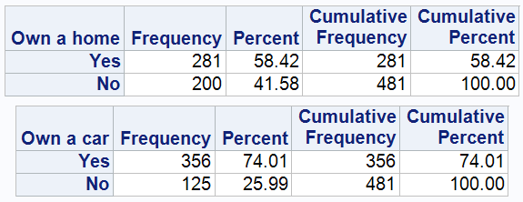The following section of this report provides relevant output from SAS to support the findings given in the Executive Summary. Additionally, annotations will be provided to give brief justifications for each piece of output and the significance in the analysis. This will follow the same structure as the main body of the Executive Summary, therefore enabling readers to better correlate where in the report the image is referring to.

Here it is observable that participants have been split into different categories. Specifically, the number of car owners is almost triple the number of non-car owners, therefore when analysing preferences, it may be reasonable to cater more towards car owner preferences as they make up the majority.

Figure 1: One-way frequencies of the different categories of participants

1. **Choosing an appropriate location for the shopping centre**

The questions with the lowest and highest responses are convenient parking and good public transport links, therefore respondents thought these to be most and least important, respectively. However, for the top 2 questions with the same modal response further methods are required. Mode was chosen as the data is ordinal and using this statistic provides some insight on the distribution of preferences. The number of responses was also shown to ensure there are no missing values.

Figure 2: relevant summary statistics for questions regarding location

Having the full one-way frequencies gives much more information than just using the mode individually. For instance, using the tables, it is observable that more people find good road links important rather than the shops being close to home. This is characterised by the next common response for good road links is “Important”, whereas with the shops being closer to home is “Slightly important”.

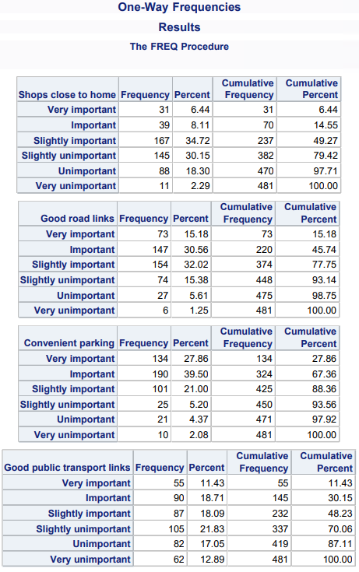

Figure 3: One-way frequencies for questions related to where a shopping centre could be located

The table shows the percentages changing depending on whether a respondent owns a car. Visually, this is a good way of showing association as the perception of whether convenient parking is important is a lot higher among car owners compared to non-car owners. Despite more car owners feeling stronger about this, from viewing the frequencies of non-car owners it is observable that they still view convenient parking as important.

Using the Chi-square test shows there is an association as the X2 is high for a very low significance level. Cramer’s V goes even further and shows that this association is medium with a value of 0.3621.

Figure 4: Table analysis, Chi-Square test for independence and Cramer's V

The percentages increase as the responses get lower depending on if the respondent owns a car, however not as much as for convenient parking. Therefore, having this in the analysis further emphasises the importance placed on convenient parking.

Here the Chi-square test still shows association, however Cramer’s V shows it is weak as the value is relatively low.

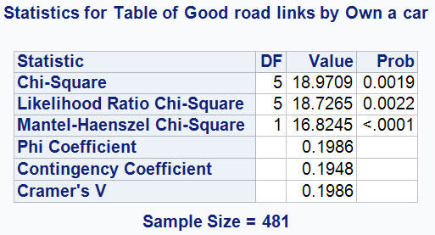

Figure 5: Table analysis, Chi-Square test for independence and Cramer's V

It is observable that car owners are more likely to view public transport links as unimportant compared to non-car owners. Additionally, since the percentages change it is necessary to test if there is association.

The Chi-square test in combination with Cramer’s V not only shows that there is an association, but that it is also of relatively medium strength.

Figure 6: Table analysis, Chi-Square test for independence and Cramer's V

The percentages increase for non-homeowners as the responses get lower, therefore showing non-homeowners are more likely to find good public transport links important than homeowners.

Chi-square test shows association and Cramer’s V shows that it is somewhat medium.

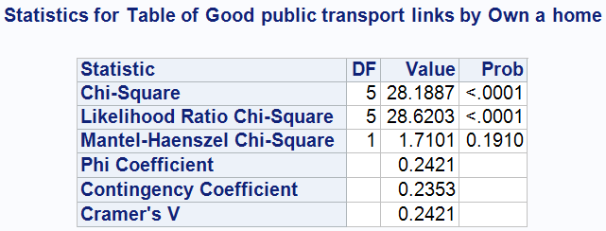

Figure 7: Table analysis, Chi-Square test for independence and Cramer's V

1. **Table

   Description automatically generatedIdentifying the potential companies that may be interested in renting a store**

Summary statistics give an approximate outline of respondent preferences. It can be observed that for the questions regarding potential companies, respondents mainly thought features were either “Important” or “Slightly important”. Each question has the same number of observations, therefore there are no missing values. Through further analysis, exact preferences can be identified.

Figure 8: Relevant summary statistics for questions regarding potential companies that may be interested in renting a store

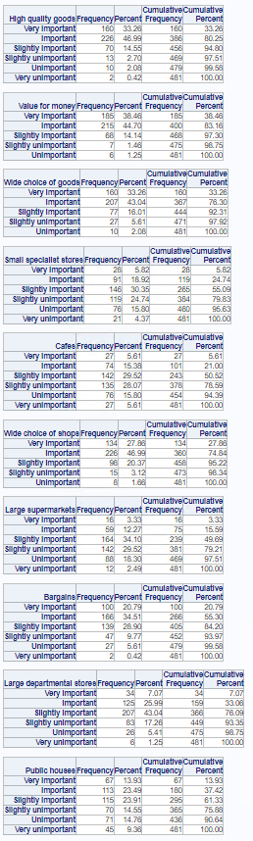

Figure 9: One-way frequencies for questions regarding potential companies that may be interested in renting a store

These one-way provide more information about customer preferences than the summary statistics as the exact percentage distributions are available. Despite many questions having the same modal answer, from these tables, value for money is observably the best rated as the highest proportion of respondents voted it “Very important” and “Important”. High quality goods are a close second, with a wide choice of goods and shops just behind. A lot can be perceived about customer attitudes with one-way frequencies individually, however more analysis is required to determine if there is any association between categories of respondents.

The same insights as above can be seen in this table analysis showing non-homeowners are more likely to find a wide choice of shops important.

The high Chi-square value with a low probability shows association and the Cramer’s V value shows it is medium strength. Additionally, because the Cramer’s V value is higher than in Figure 9, the association is observably stronger.

The percentages increase as the responses decrease, therefore reinforcing that non-homeowners are more likely to find a wide choice of goods important than homeowners.

The high Chi-square value with a low probability and Cramer’s V value show there is a medium association between owning a home and wanting a wide choice of goods in a shopping centre.

Figure 11: Table analysis, Chi-Square test for independence and Cramer's V

Figure 10: Table analysis, Chi-Square test for independence and Cramer's V

The percentage of homeowners increases as the response gets lower. Therefore, homeowners are more likely to view public houses as important compared to non-homeowners.

The high Chi-square value with the low probability shows association and the Cramer’s V value shows the association is medium.

The table shows that homeowners are more likely to view large departmental stores as unimportant compared to non-homeowners. Specifically, the percentage of homeowners increases as the response gets higher.

The high Chi-square value with a low probability and Cramer’s V value show there is a medium association between whether respondents own a home and their views on the importance of large departmental stores in shopping centres. The Cramer’s V value shows that the strength of the association is medium.

Figure 13: Table analysis, Chi-Square test for independence and Cramer's V

Figure 12: Table analysis, Chi-Square test for independence and Cramer's V

1. **Table

   Description automatically generated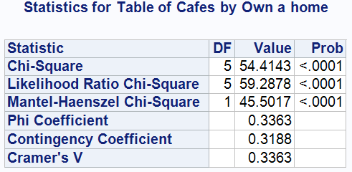**Table

   Description automatically generated**Designing the centre’s facilities and layout**

Figure 14: Table analysis, Chi-Square test for independence and Cramer's V

The summary statistics show general participant preferences. Specifically, from the table, it is immediately observable baby feeding/changing areas and places to leave children is unimportant to respondents. Additionally, questions with modal answers of 2 are the most important and further analysis is required to identify which of these is a priority.

The percentage of homeowners increases as the response gets higher. Therefore, homeowners are more likely to perceive cafes as unimportant compared to non-homeowners.

The high Chi-square value with the low probability shows association and the Cramer’s V value shows the association is medium.

Figure 15: Relevant summary statistics for questions regarding designing the layout and facilities

One-way frequencies to go more in depth about participant preferences. From the summary statistics there are 9 questions where the modal answer was “Important”. Having this be part of the analysis is necessary as it identifies the exact preference distribution and enables readers to observe which features were most favourable. Specifically, enjoying yourself is the most important as the largest number of respondents found it to be “Very important” (Figure 16) with shops being easily findable just behind it. Although there are other questions with many respondents perceiving them as important being able to view the exact amount gives better insights when trying to rank them.

Figure 16: One-way frequencies for questions regarding the design of the layout and facilities/amenities of a shopping centre (1)

Figure 17: One-way frequencies for questions regarding the design of the layout and facilities/amenities of a shopping centre (2)

Here are the rest of the one-way frequencies for the questions concerning what facilities should be in a shopping centre with the highest modal answers being highlighted. When looking at just these highlighted values it is observable that pedestrian zones are the last favourable. This is because the number of participants that perceive it as either “Slightly important”, “Important and “Very important” is smaller than the others. Additionally, the number of participants that view it as “Unimportant” and “Very unimportant” is higher than the rest. These are key insights not available with just the mode.

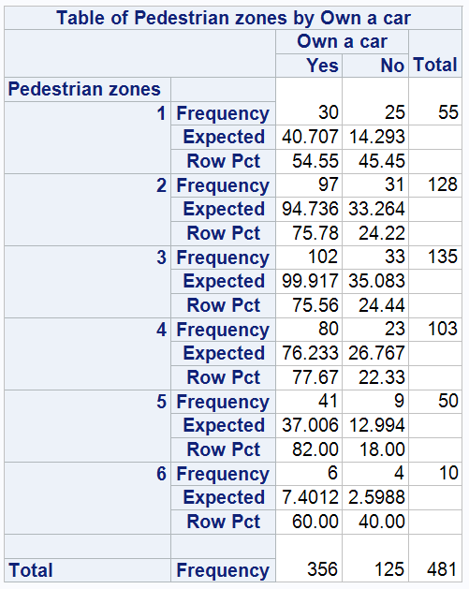

The percentage of homeowners increases as the response gets higher. Therefore, homeowners are more likely to perceive toilets as unimportant compared to non-homeowners.

The high Chi-square value with the low probability shows association and the Cramer’s V value shows the association is medium.

The percentage of car owners to non-car owners is approximately 3:1, see *Figure 1*, therefore the middle responses are relatively evenly split. However, for “Very important” the number of non-car owners is a lot higher than this ratio, thus non-car owners view pedestrian zones as more important than car owners.

Figure 19: Table analysis

Figure 18: Table analysis, Chi-Square test for independence and Cramer's V

**Appendix**

**Questionnaire to measure Consumer Preferences**

1. staying dry
2. high quality goods
3. value for money
4. helpful staff
5. clean shopping areas
6. a wide choice of goods
7. shops being close to your home
8. staying warm
9. good road links
10. small specialist stores
11. convenient parking
12. being able to easily find the shops you are looking for
13. friendly staff
14. places to sit down
15. easy access to information about the shops
16. cafes
17. an attractive looking shopping area
18. toilets
19. a wide choice of shops
20. large supermarkets / hypermarkets
21. a baby feeding / changing area
22. good public transport links
23. places to meet others
24. shopping with friends
25. getting a bargain
26. enjoying yourself
27. large departmental stores
28. litter-free shopping areas
29. a place to leave children
30. security staff
31. short distance between shops
32. pedestrian zones
33. public houses
34. Do you own a home?
35. Do you own a car?

**References**

Radojka, K. and Filipović, Z., 2017. Gender differences and consumer behavior of millennials. *Acta Economica Et Turistica*, *3*(1), pp.5-13.

Ahmed, Z.U., Ghingold, M. and Dahari, Z., 2007. Malaysian shopping mall behavior: an exploratory study. *Asia Pacific Journal of Marketing and Logistics*.

Boone, H.N. and Boone, D.A., 2012. Analyzing likert data. *Journal of extension*, *50*(2), pp.1-5.

Zibran, M.F., 2007. Chi-squared test of independence. *Department of Computer Science, University of Calgary, Alberta, Canada*, *1*(1), pp.1-7.

McHugh, M.L., 2013. The chi-square test of independence. *Biochemia medica*, *23*(2), pp.143-149.